**Traveling Salesman Problem: Brute Force**

Jacob Taylor Cassady

Computer Engineering & Computer Science

Speed School of Engineering

University of Louisville, USA

[jtcass01@louisville.edu](mailto:NameID@louisville.edu)

1. **Introduction**

The Traveling Salesman Problem (TSP) is a well-known non-deterministic polynomial-time hard problem that has been studied within mathematics since the 1930s. The "salesman” is given a list of cities with their locations and is asked the shortest route to travel to each city once and then return to the starting point. A program was developed using Python 3.7 and accompanying 3rd party libraries: NumPy, Pandas, and matplotlib to determine the shortest path.

1. **Approach**

The approach for solving the TSP was brute force. Throughout this document cities will be referred to as “vertices” and the route between the vertices as “edges.” A simplified version of the algorithm designed is shown in Figure 1 of the Appendix.

A “Route” is initialized at the starting vertex.  A recursive function is then used to take all available routes from that vertex with each stop at an adjacent vertex making a deeper call to the same recursive function.  Once the Graph’s vertices have been visited, the route returns to the starting vertex and is kept until all routes have been generated.  Finally, the routes are compared to find the route with minimum distance traveled.  For graphs with less than 10 vertices, a list of routes is kept in RAM and quickly compared at the end.  Since the amount of routes grows the algorithms runtime factorially, the routes need to be moved to hard disk at 10 or more and compared after being generated.

1. **Results**

The algorithm successfully produces a minimum route; although, there are some drawbacks. Since the algorithm is recursive in nature and the TSP grows with factorial complexity, memory use and computational cost becomes an issue quickly as you increase the number of cities. Mitigation techniques for the memory burden are described in the approach section of this document.

* 1. **Data**

The algorithm was tested using 9 different datasets each with a different number of cities starting at 4 and ending at 12. Cities are enumerated and x and y coordinates are provided. The input data was formatted like the example below:

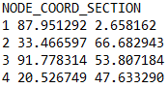

* 1. **Results**

Please refer to the following table for the optimal paths computed for each input file (note: filenames tagged with * denotes the routes were written to disk instead of being kept in RAM during generation):

|  |  |  |  |  |
| --- | --- | --- | --- | --- |
| Filename | Number of Cities | City Order | Distance Traveled | Algorithm Runtime |
| Random4.tsp | 4 | 0, 3, 1, 2, 0 | 215.086 | 0.0029s |
| Random5.tsp | 5 | 0, 1, 4, 2, 3, 0 | 139.133 | 0.0259s |
| Random6.tsp | 6 | 0, 1, 2, 3, 4, 5, 0 | 118.969 | 0.0858s |
| Random7.tsp | 7 | 0, 1, 6, 2, 5, 4, 3, 0 | 63.863 | 0.5166s |
| Random8.tsp | 8 | 0, 5, 7, 3, 4, 1, 2, 6, 0 | 310.982 | 3.9385s |
| Random9.tsp | 9 | 0, 6, 5, 2, 4, 1, 8, 3, 7, 0 | 131.028 | 35.0865s |
| Random10.tsp* | 10 | 0, 1, 6, 5, 7, 4, 8, 9, 3, 2, 0 | 106.786 | 449.1541s |
| Random11.tsp* | 11 | 0, 5, 9, 10, 7, 8, 6, 4, 2, 3, 1, 0 | 252.684 | 4768.5063s |
| Random12.tsp* | 12 | 0, 7, 1, 2, 11, 3, 8, 4, 9, 5, 6, 10, 0 | 66.085 | 57517.0233s |

A graph of the number of cities within a file vs. the average algorithm runtime is shown in Figure 2 of the Appendix. Graph visualizations were created for each file’s input/output to ensure the results were reasonable. These can be found in the Appendix as well, Figures 3 through 20.

1. **Discussion**

As you can see from the graph within the appendix and the table above, the algorithm’s runtime grows very quickly as the number of cities increase. This is a consequence of the algorithm’s factorial complexity. Runtime could be further reduced by using the logging technique mentioned in the Approach section of this document while spawning a separate process for each route after it visits its second city. Depending on the number of processor cores available, you could speed up the runtime by a factor equal to the number of CPU cores utilized with some limitations for datasets with more cities than available CPU cores.

1. **References**

Wikipedia, Traveling Salesman Problem - <https://en.wikipedia.org/wiki/Travelling_salesman_problem#History>

NumPy Documentation - <https://docs.scipy.org/doc/>

Pandas Documentation - <https://pandas.pydata.org/pandas-docs/stable/>

Matplotlib Documentation - <https://matplotlib.org/3.1.1/contents.html>

1. **Appendix**

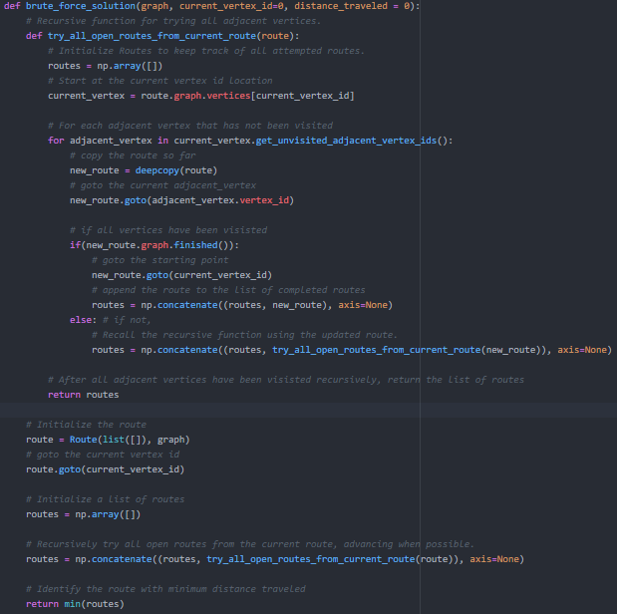

Figure : Brute Force Algorithm

Figure : Average Algorithm Runtime Graph

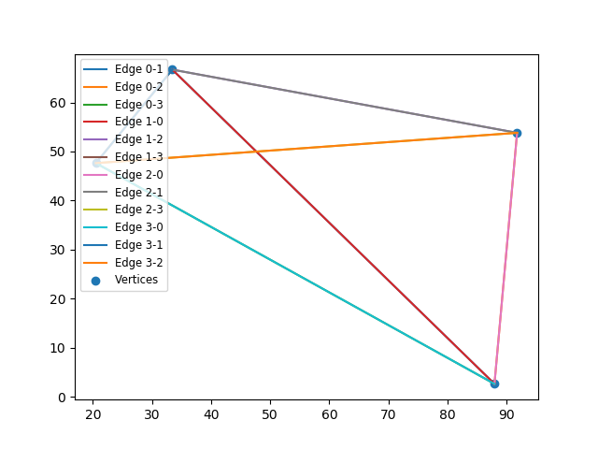

Figure : Random4.tsp Input

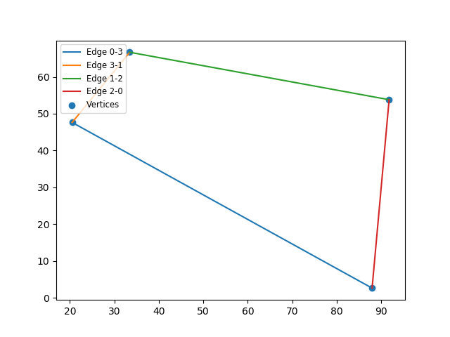

Figure : Random4.tsp Output

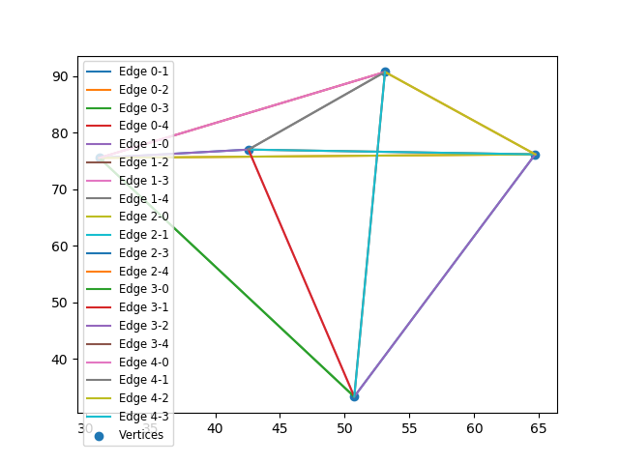

Figure : Random5.tsp Input

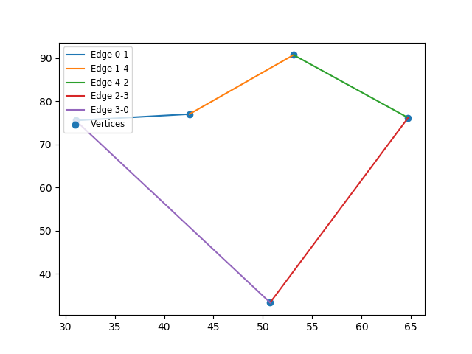

Figure : Random5.tsp Output

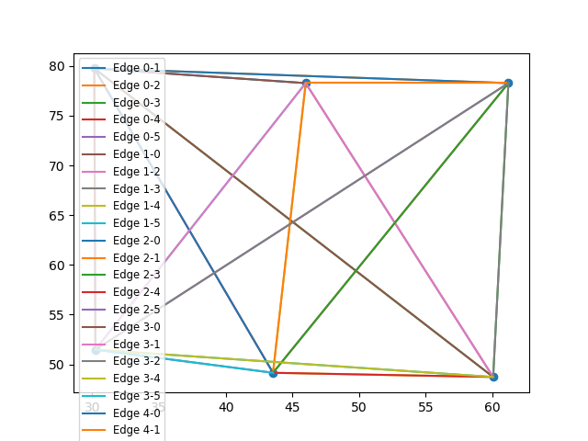

Figure : Random6.tsp Input

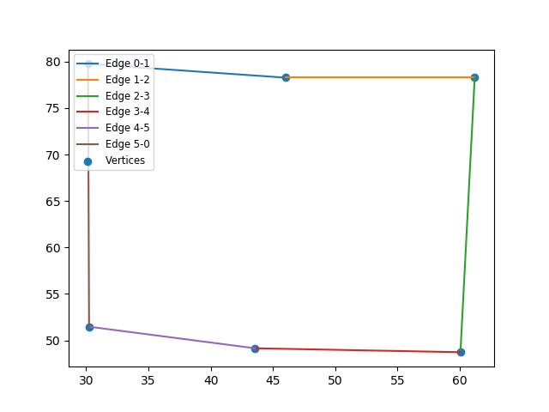

Figure : Random6.tsp Output

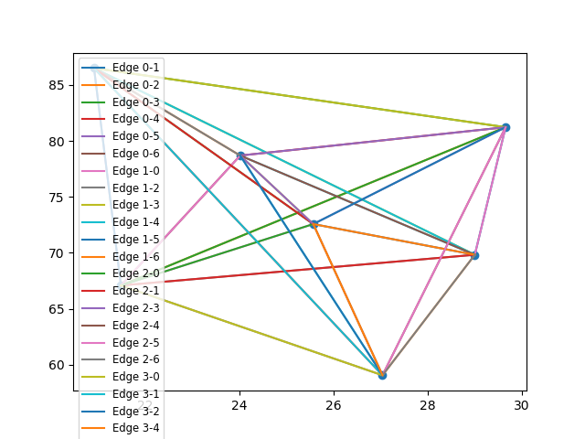

Figure : Random7.tsp Input

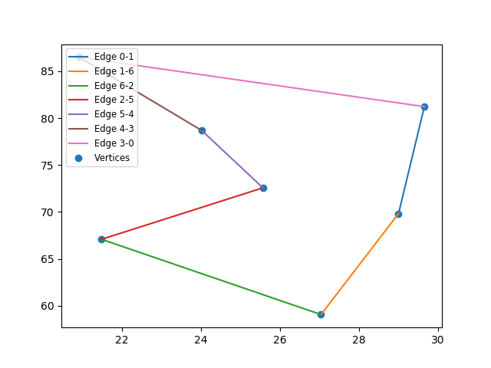

Figure : Random7.tsp Output

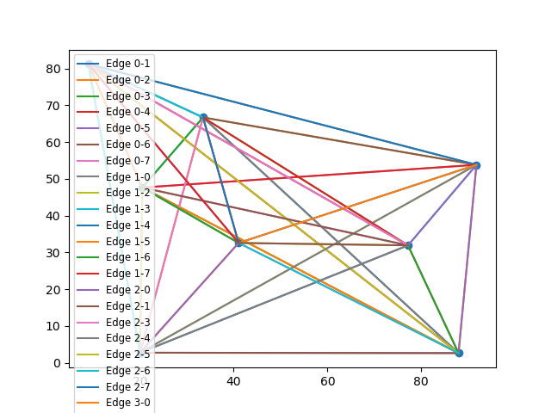

Figure : Random8.tsp Input

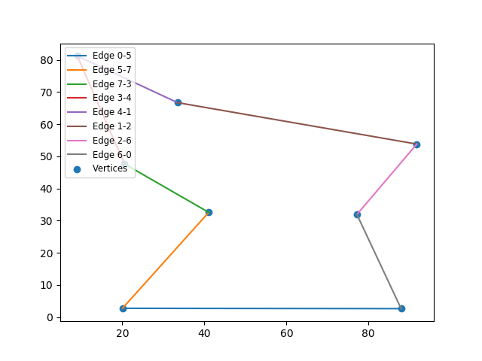

Figure : Random8.tsp Output

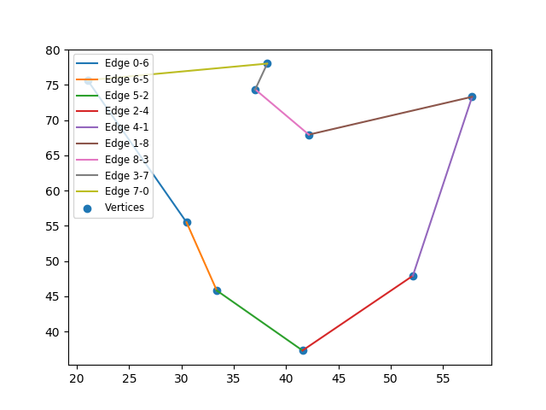

Figure : Random9.tsp Input



Figure : Random9.tsp Output

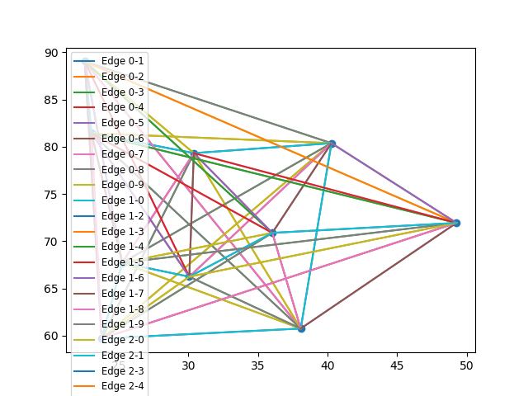

Figure : Random10.tsp Input

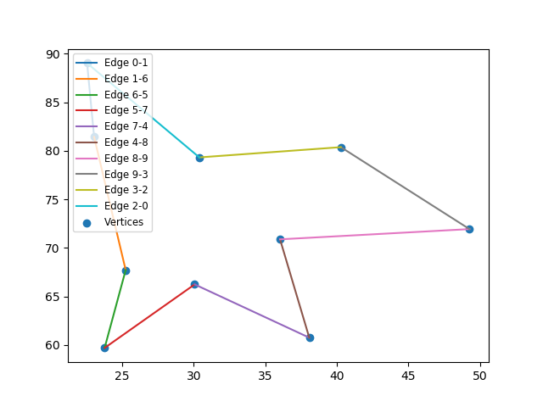

Figure : Random10.tsp Output

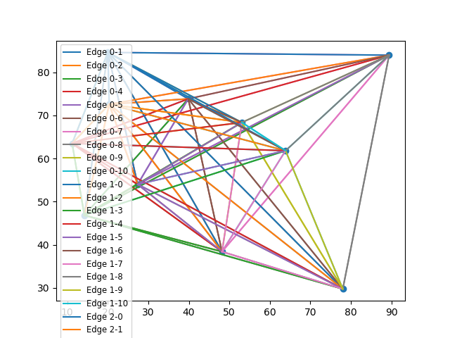

Figure : Random11.tsp Input

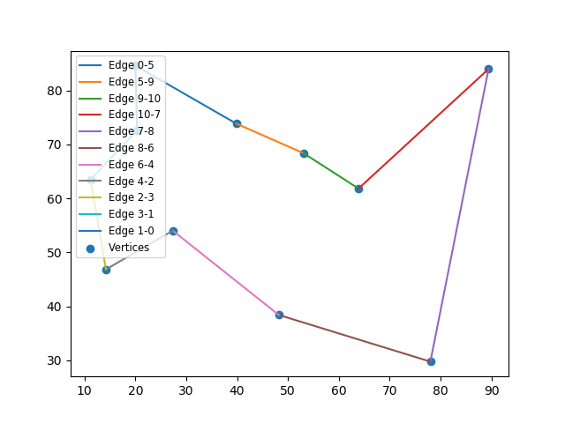

Figure : Random11.tsp Output

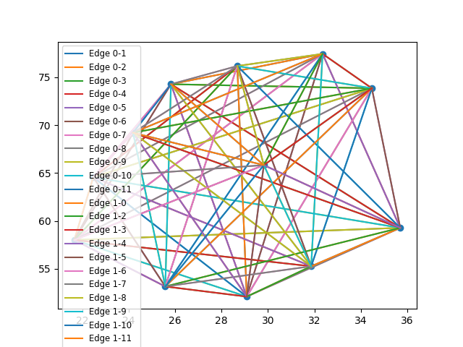

Figure : Random12.tsp Input

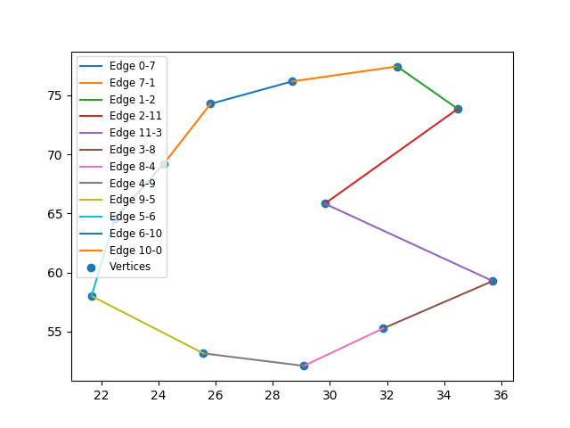

Figure : Random12.tsp Output